**Assignment L06 - Chihuahua or Muffin**

**Team EyeConic**

**Brooke Broderick - W217065417**

**Matthew Choo - W206744145**

**Cameroun White-W216530571**

**Melvis Maduagwu-W216890463**

**Erick Banegas - W216200956**

**NancyChieu-W000098778**

**Yoana Cook - W215913890**

**6252-ITAI-1378-Comp Vision-Artificial Intel-RT-15698 - Spring 2025**

**Professor Anna Devarakonda**

**March 1, 2025**

**Intro**

* In this L06, team EyeConic will be working at a “Chihuahua or Muffin: workshop. This is where we will be exploring the image classification machine learning techniques. Have to clone a Github repository and put it on a jupyter notebook, AWS SageMaker Studio Lab or Google Colab. We will be learning three types of concepts which are image classification, convolutional neural networks and transfer learning. Image classification is a type of fundamental task where it does a “vision recognition that aims to understand and categorize” the image as a “whole under a specific label”(paperswithcode). Convolutional Neural Network is a type of “deep learning algorithm that analyzes and learns visual features” from specific images (Tech Target). It is also used to “recognize patterns in images” that have been “commonly used for image recognition, object detection and classification”(Tech Target). Lastly, transfer learning is a type of machine learning technique where the knowledge is “gained through one task or dataset” that is being “used to improve model performance on another related task and/or different datasets” (IBM). In figures 1 - 22, we will be running the code and fixing the errors it gives us.

Workshop_1.ipynb Original Cod

**Yoana Cook**

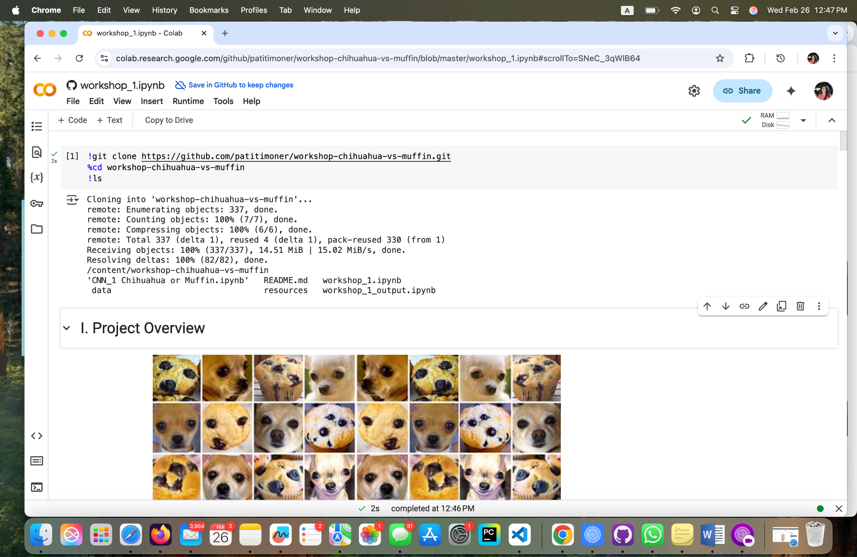

**Fig 1- Yoana Cook: Clone the entire repository from GitHub**

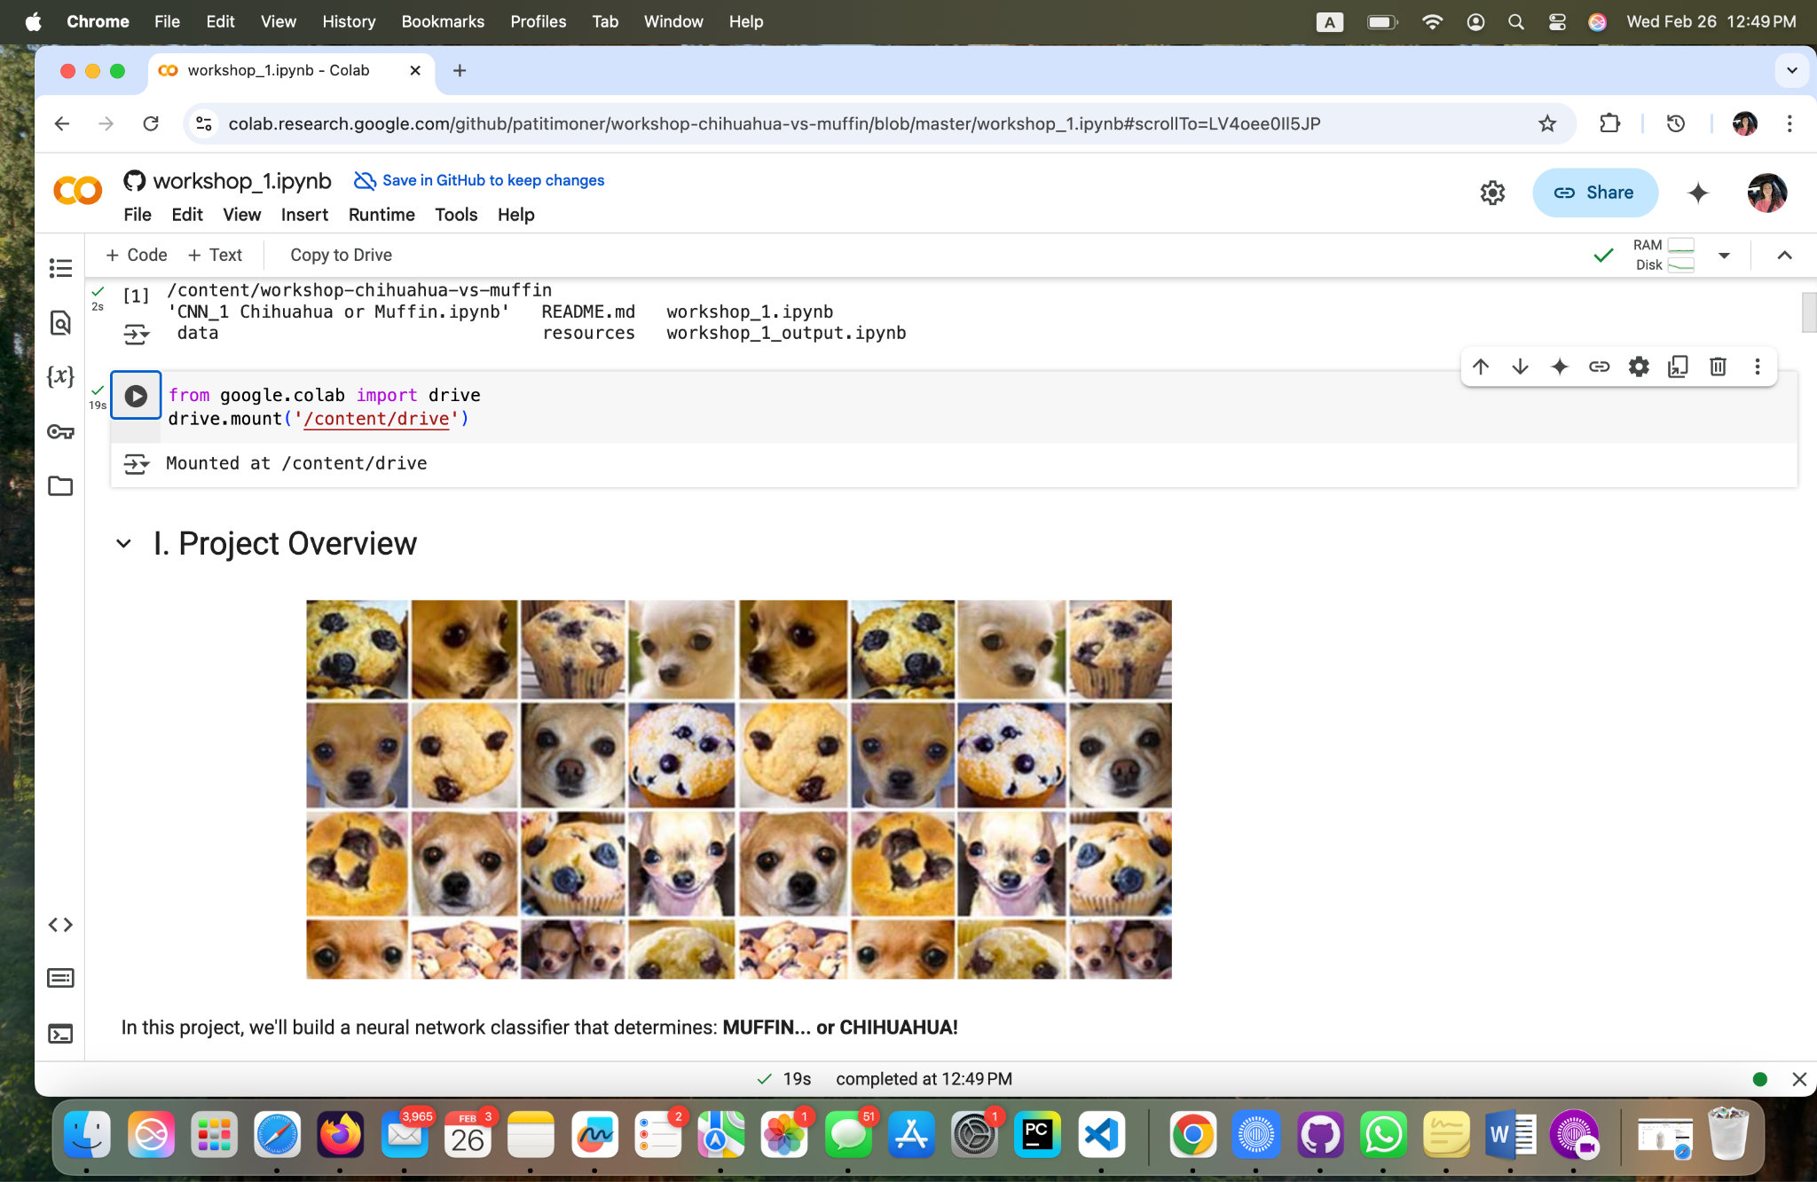

**Fig 2 – Yoana Cook: Mounting the content to Google Drive**

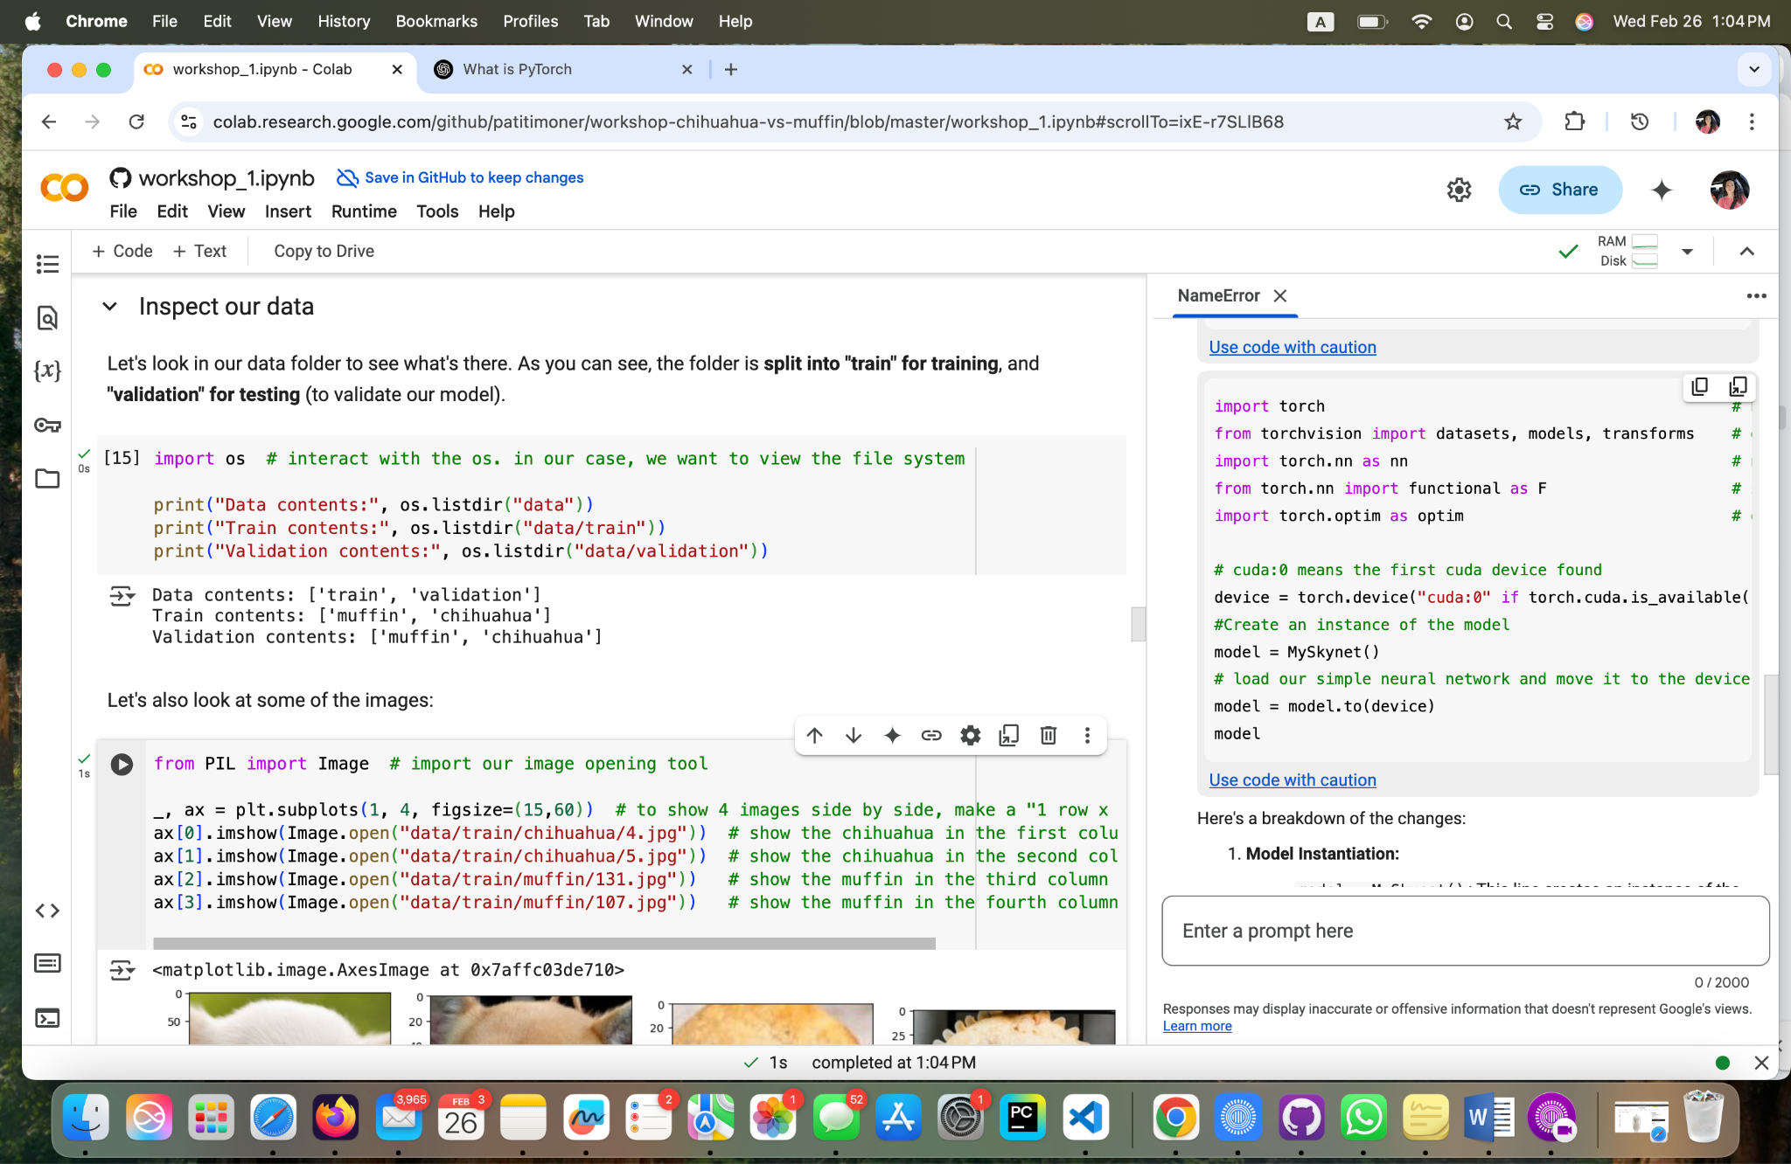

**Fig 3 – Yoana Cook: Import Libraries**

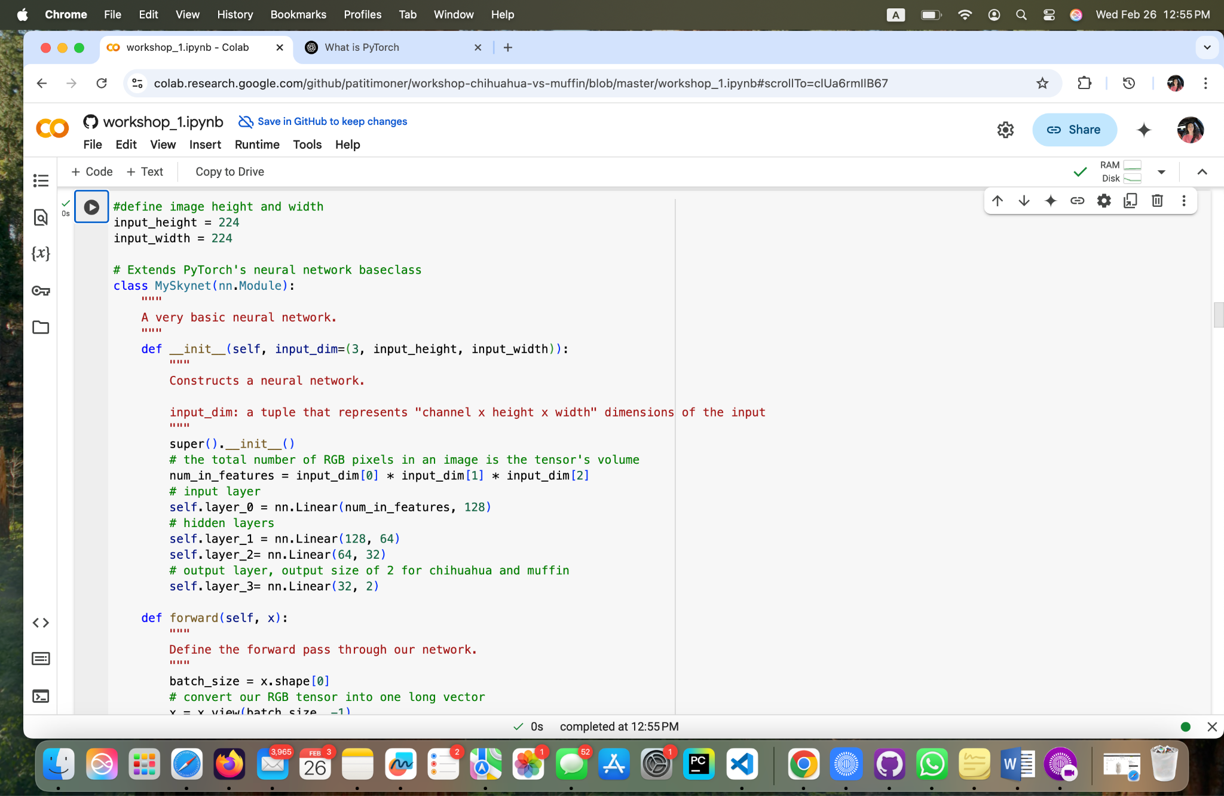

**Fig 4 - Yoana Cook: Feedforward Neural Network using PyTorch's nn.Module class; Part1.**

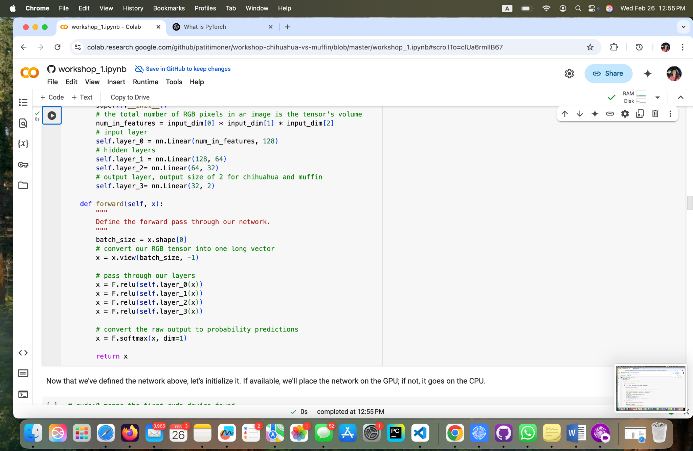

**Fig 5 - Yoana Cook: Feedforward Neural Network using PyTorch's nn.Module class; Part2.**

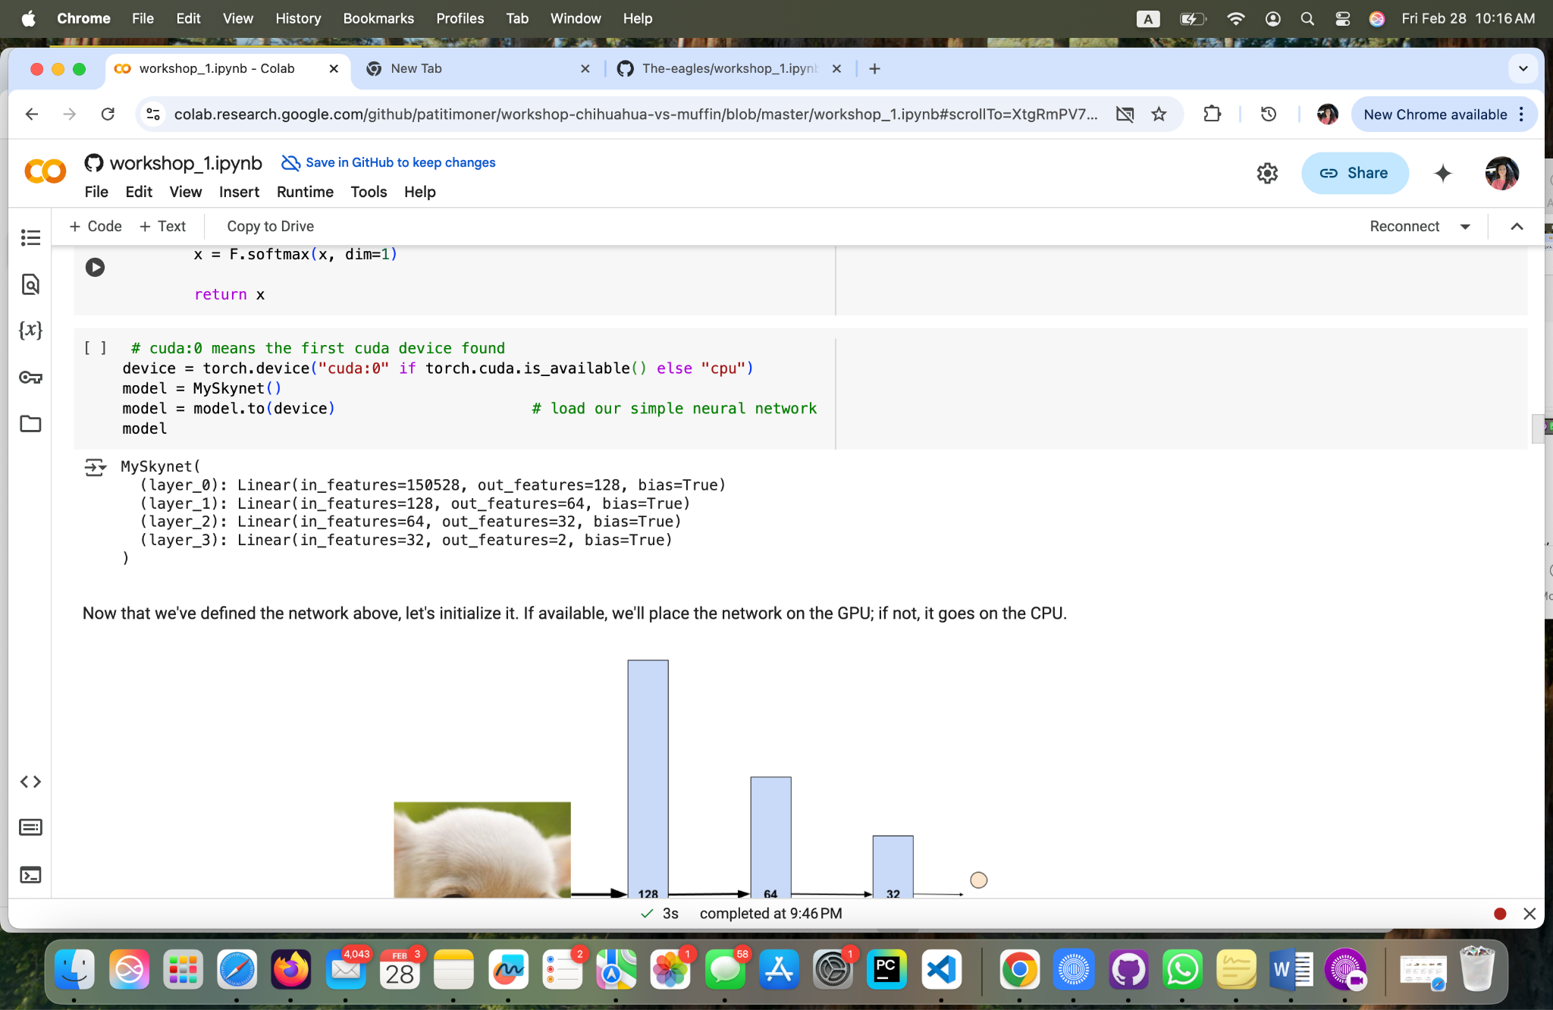

**Fig 6 - Yoana Cook: Setting up the device (CPU or GPU) for PyTorch model and loading the model onto that device.**

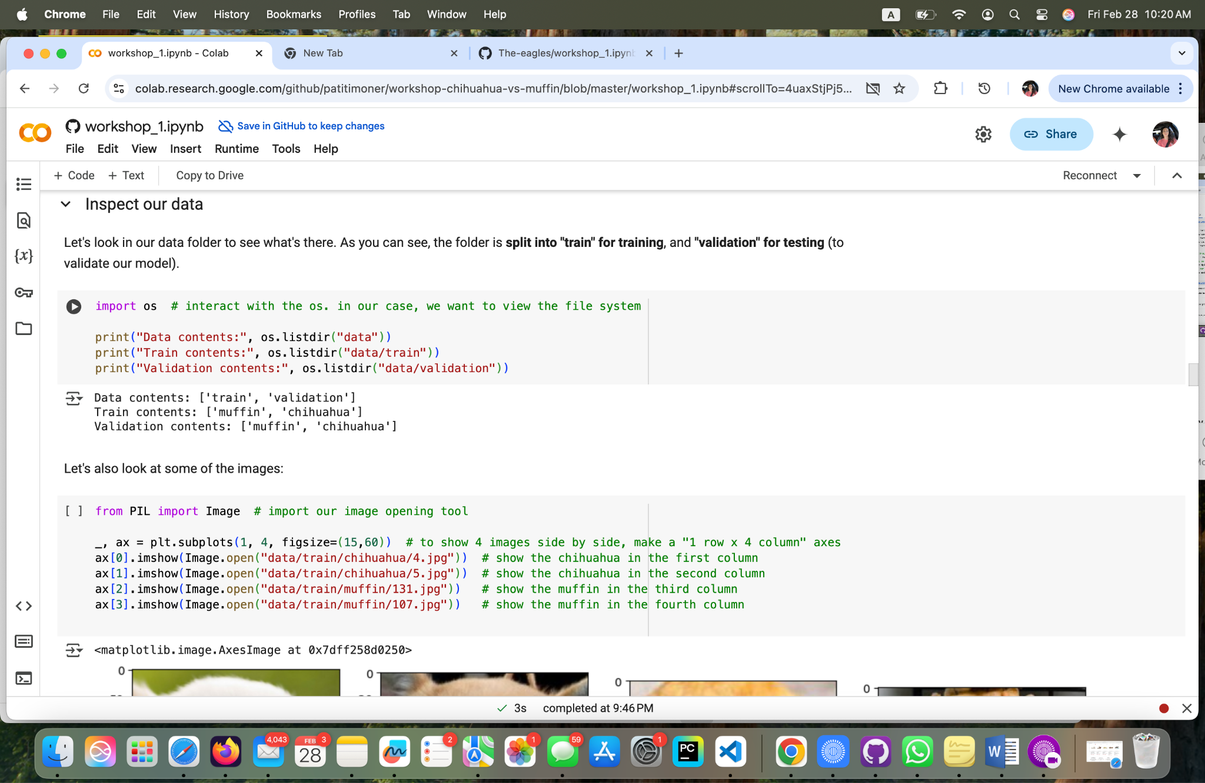

**Fig 7 - Yoana Cook: Code for Directory Inspection and Image Visualization**

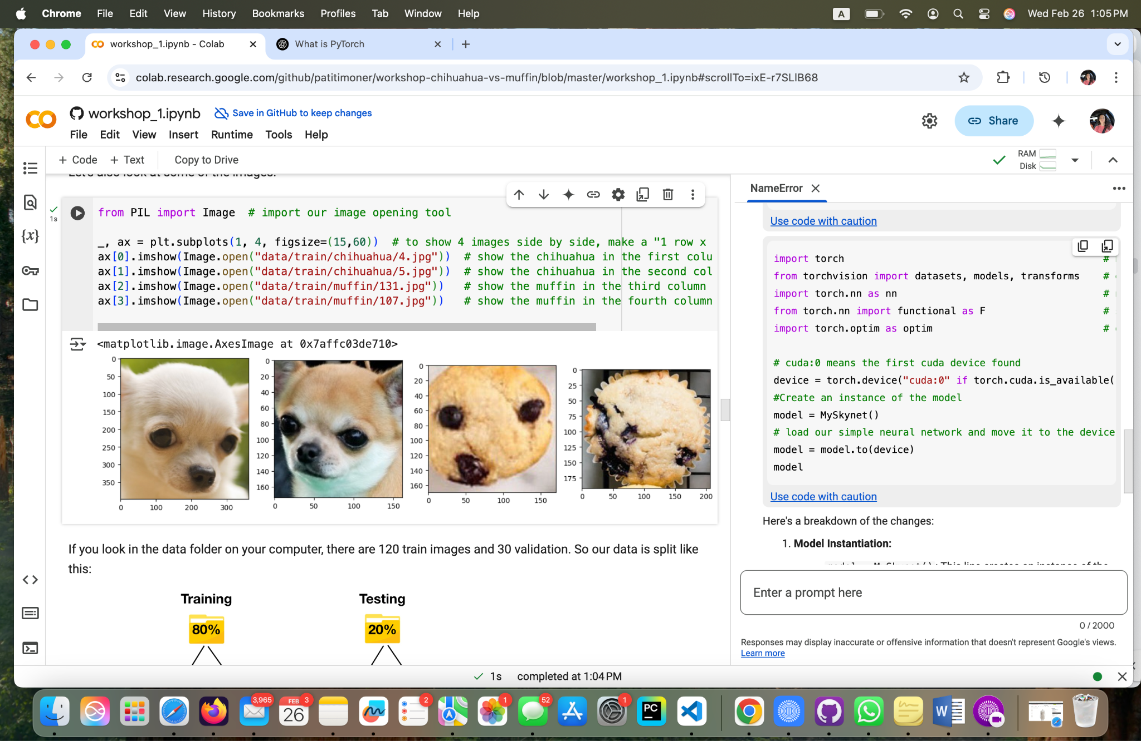

**Fig 8: Inspected and Visualized Chi Images.**

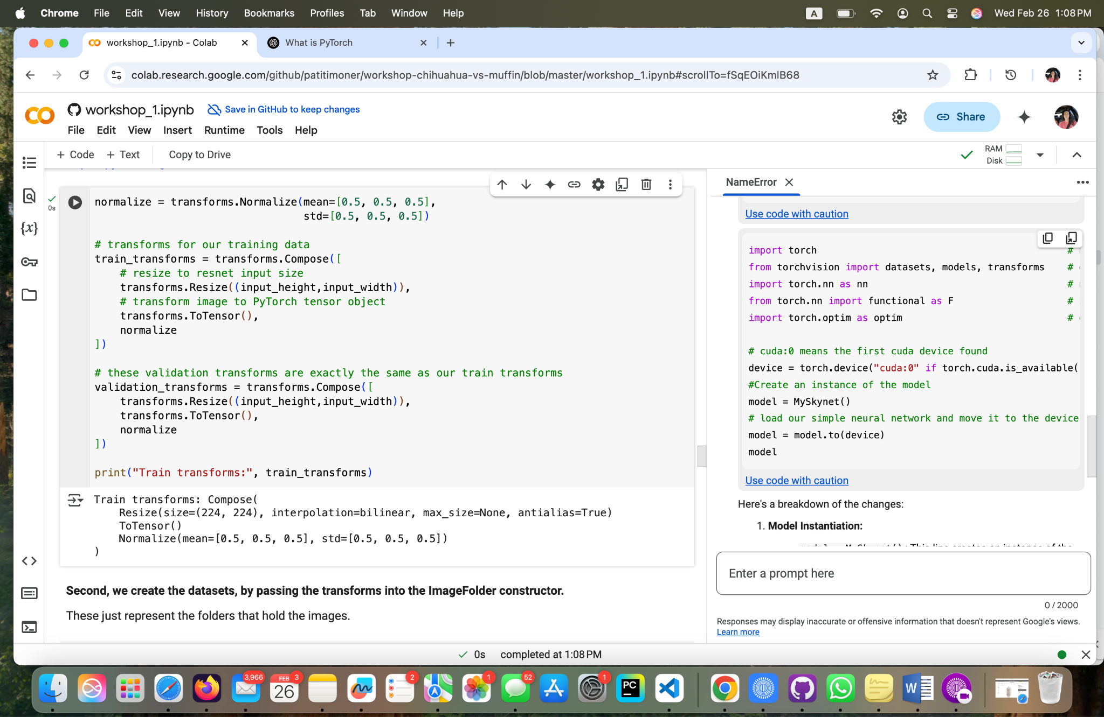

**Fig 9 - Yoana Cook: Defining image transformation pipelines for training and validation datasets.**

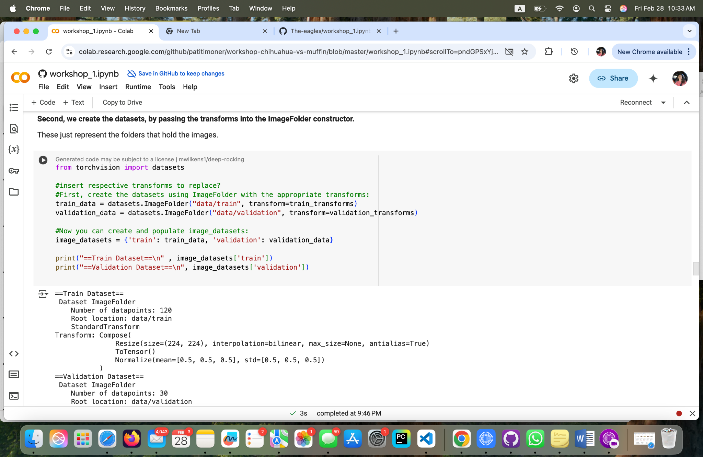

**Fig 10 - Yoana Cook: Creating training and validation datasets using Image Folder.**

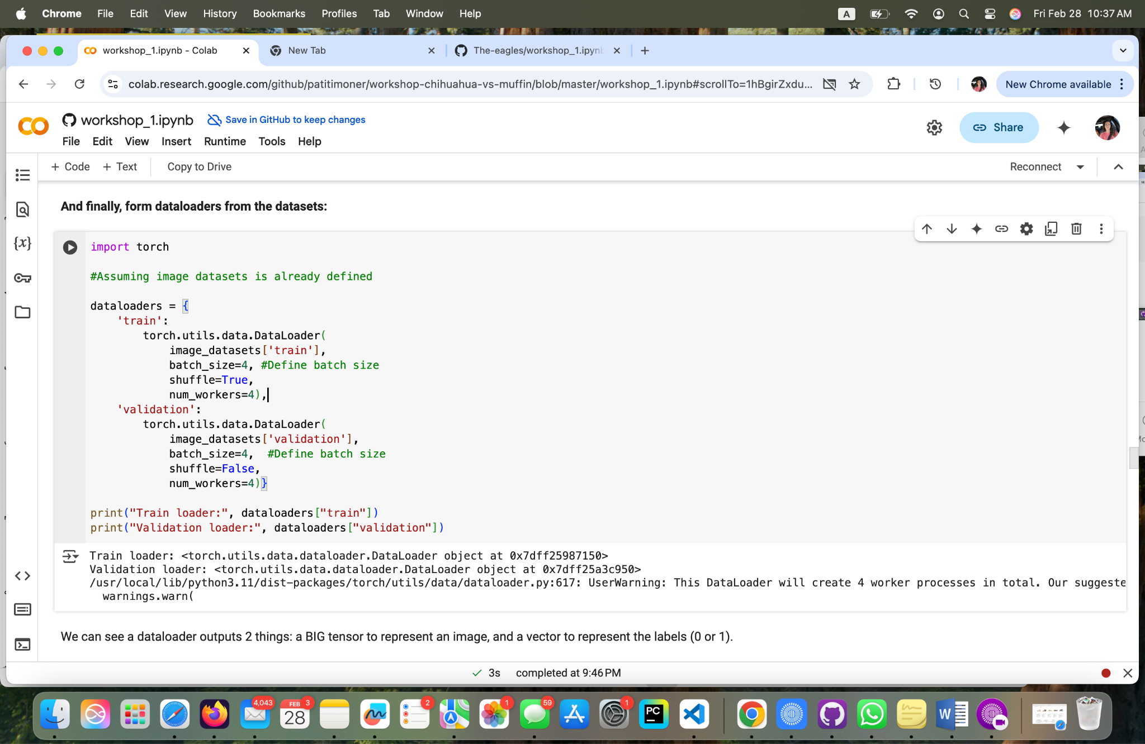

**Fig 11 - Yoana Cook: Creating data loaders for training and validation datasets using torch.utils.data.DataLoaders**

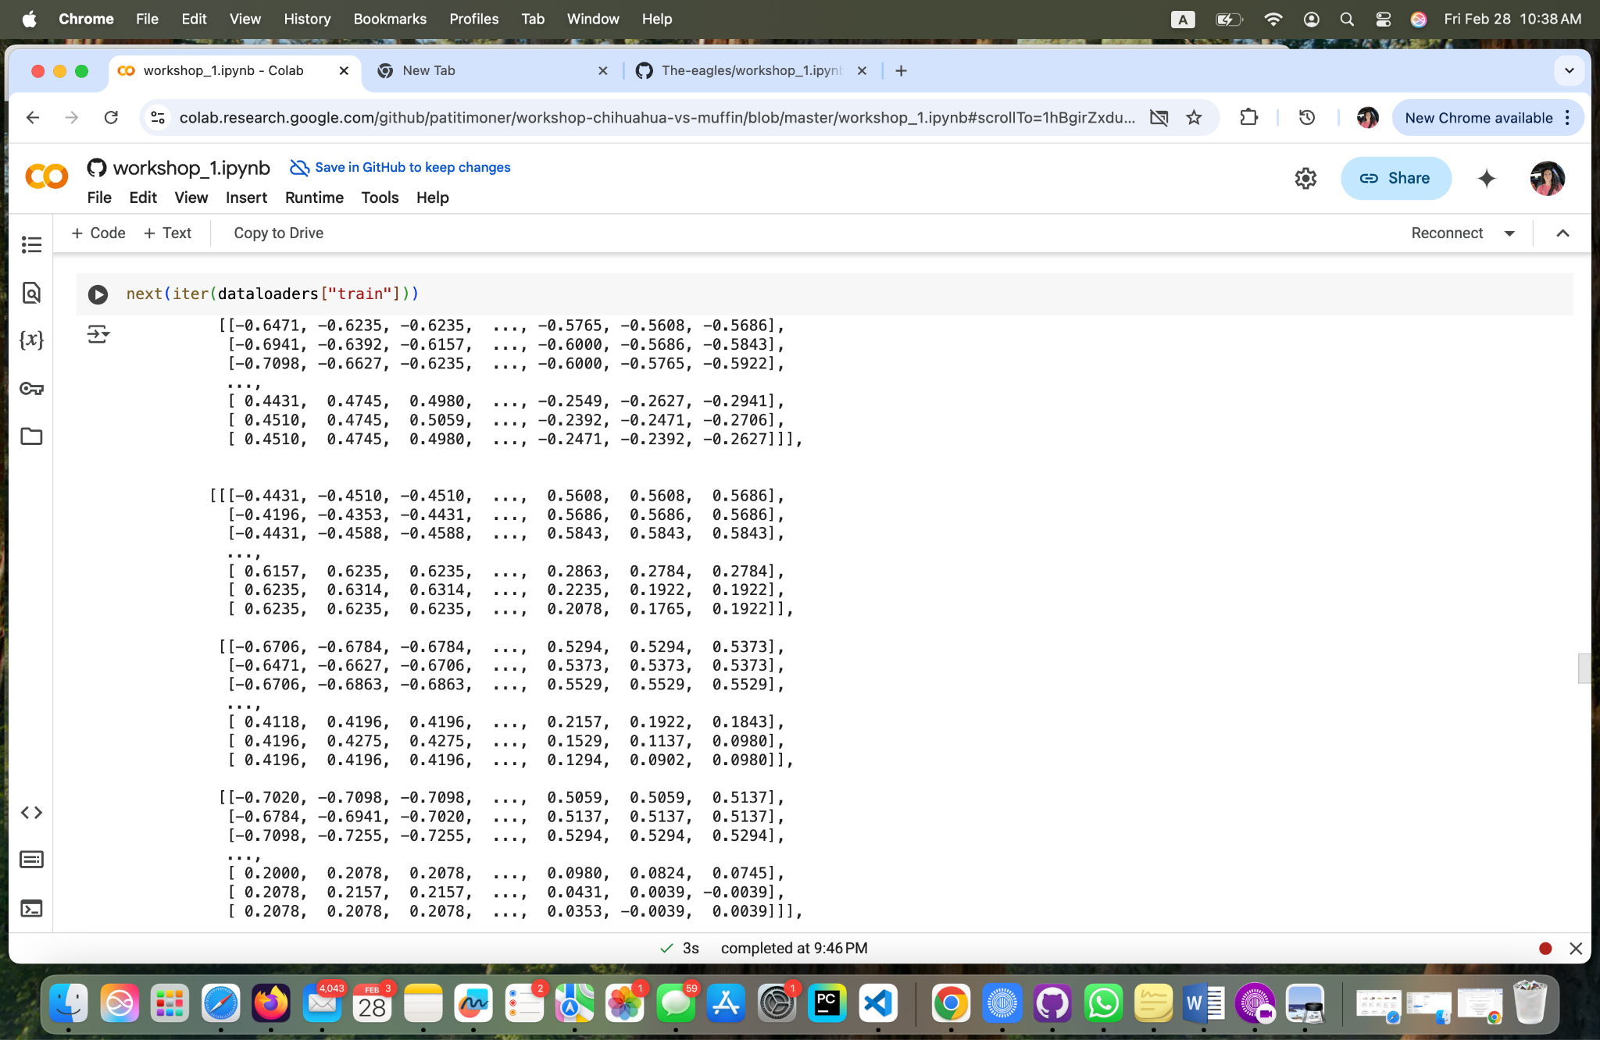

**Fig 12 - Yoana Cook: Results**

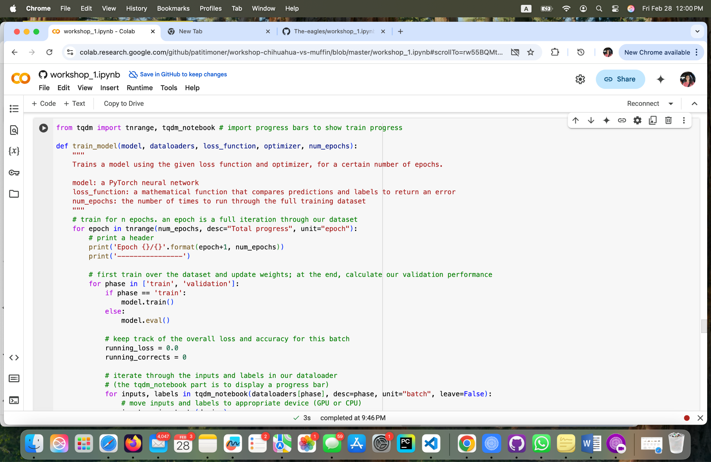

**Fig 13 - Yoana Cook: Defining a function to train a Neural Network mode Part 1**

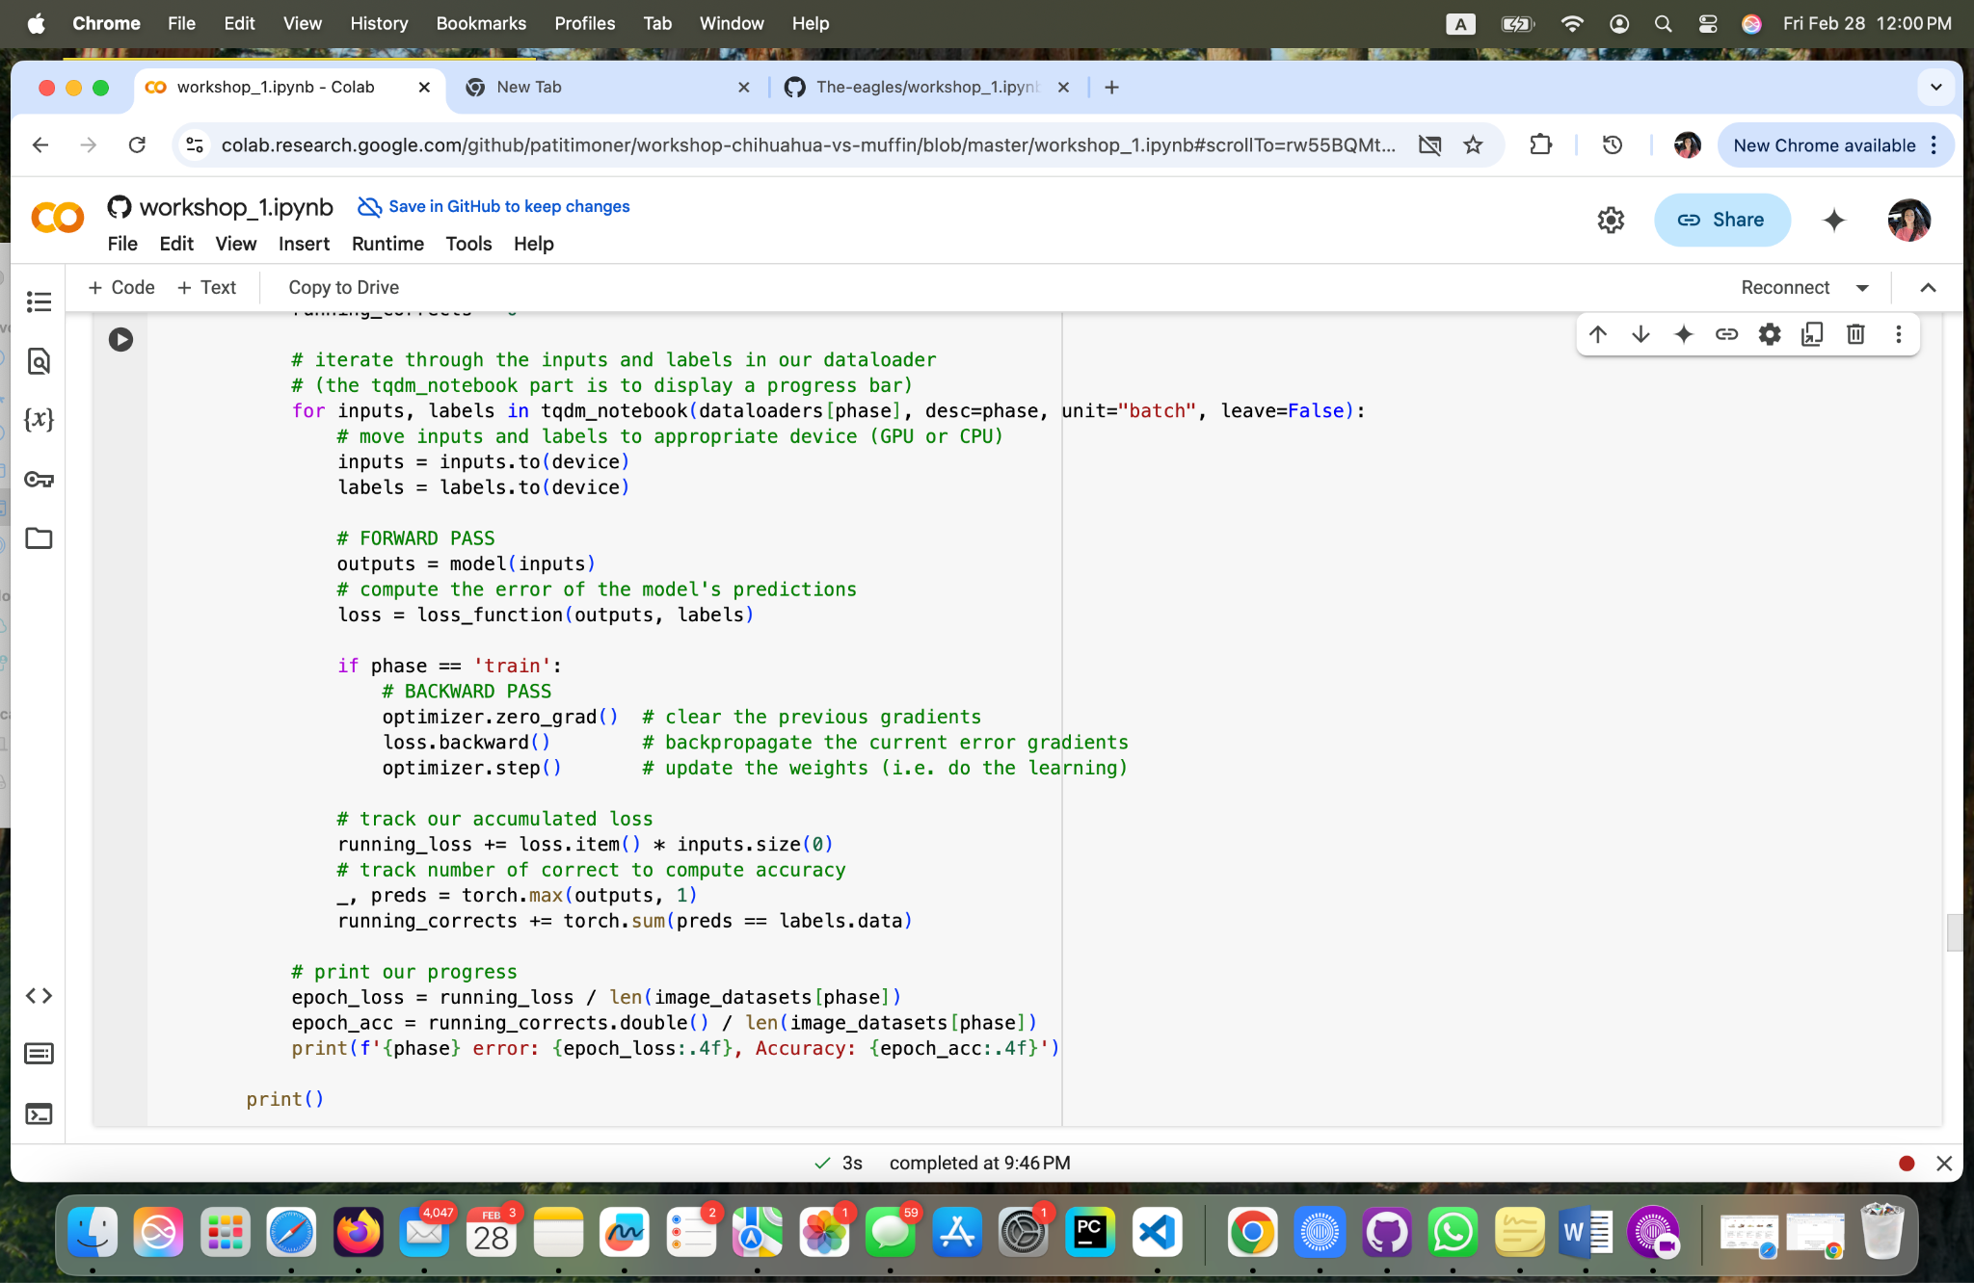

**Fig 14 - Yoana Cook: Defining a function to train a Neural Network mode Part 2**

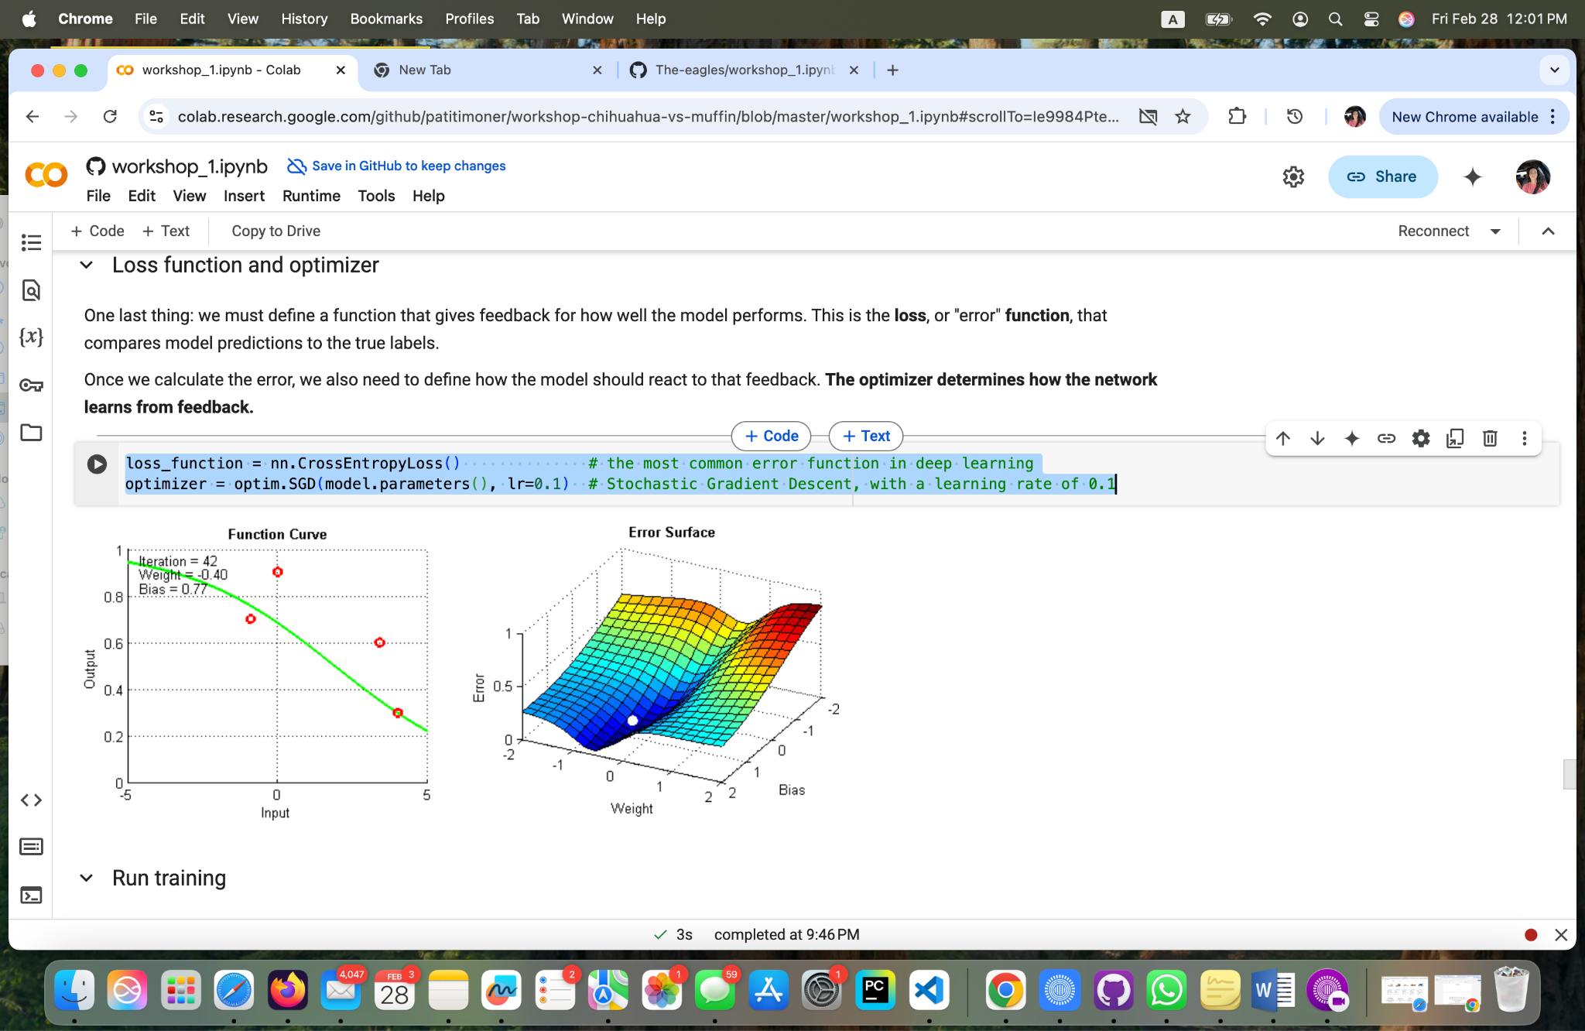

**Fig 15 - Yoana Cook: Defining Loss Function and Optimizer**

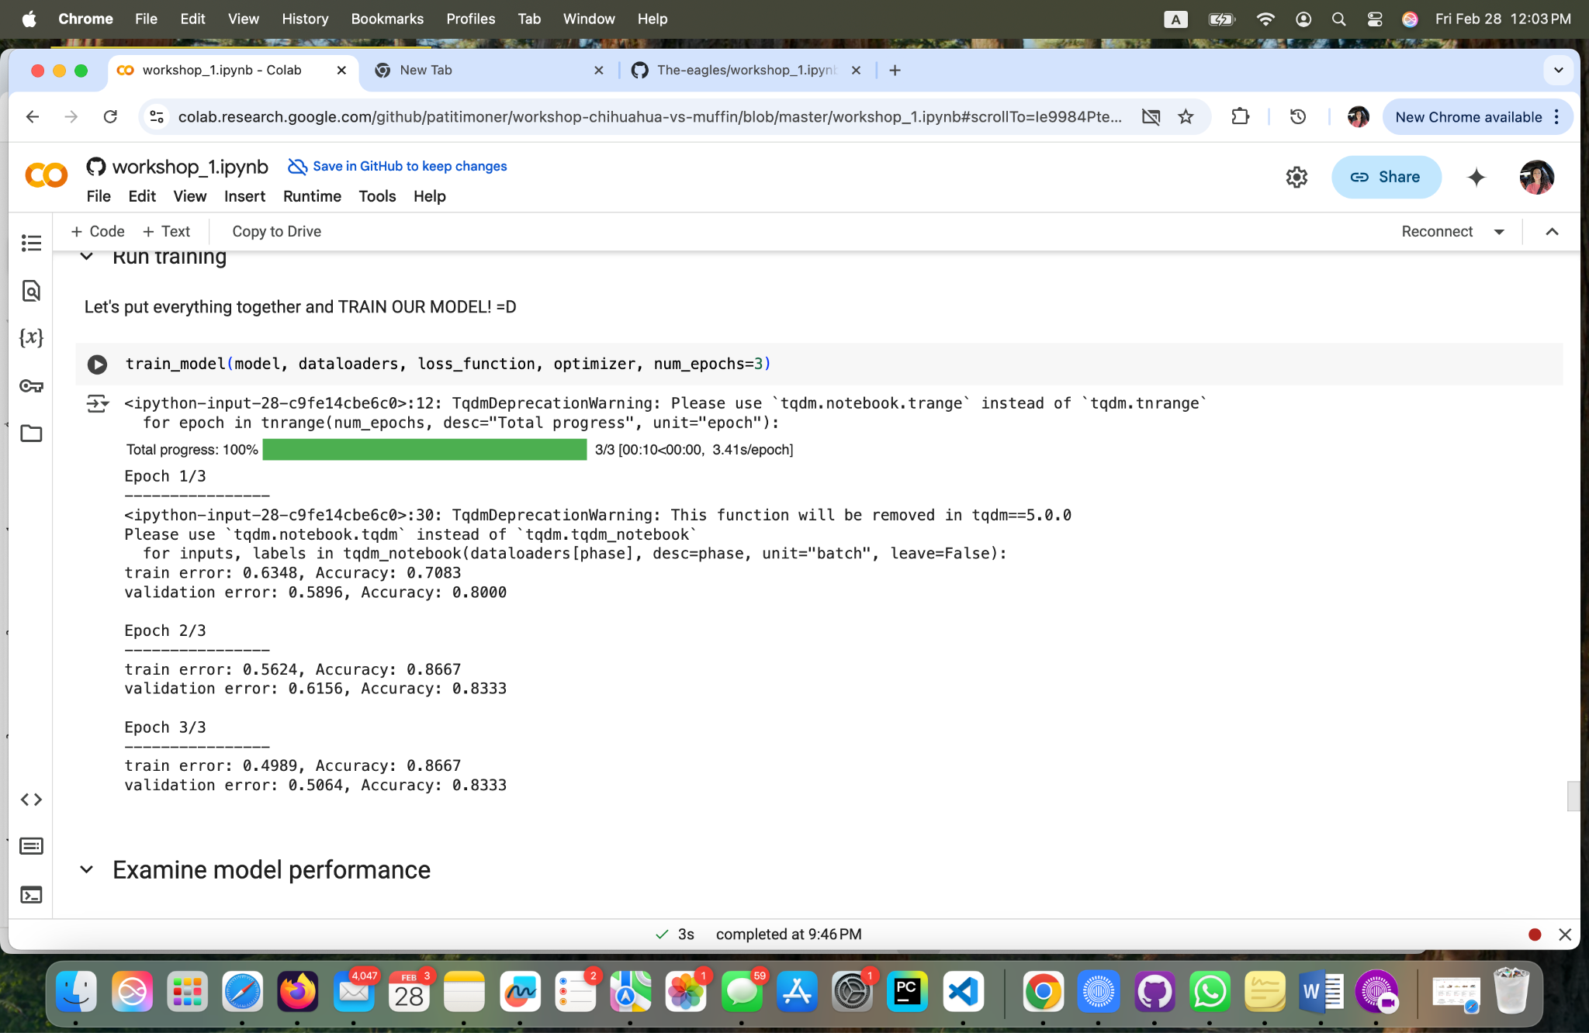

**Fig 16 - Yoana Cook: Run training**

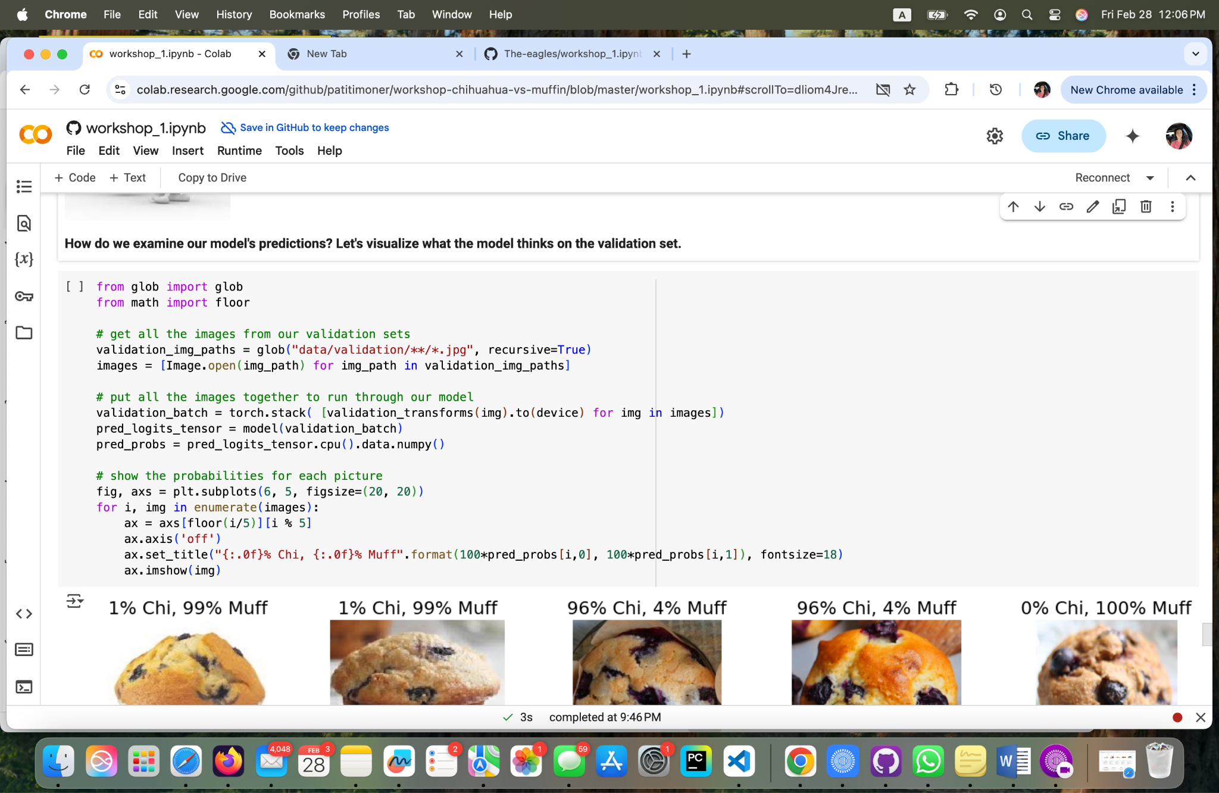

**Fig 17 - Yoana Cook: Visualizing Model Predictions on Validation Images Part 1**

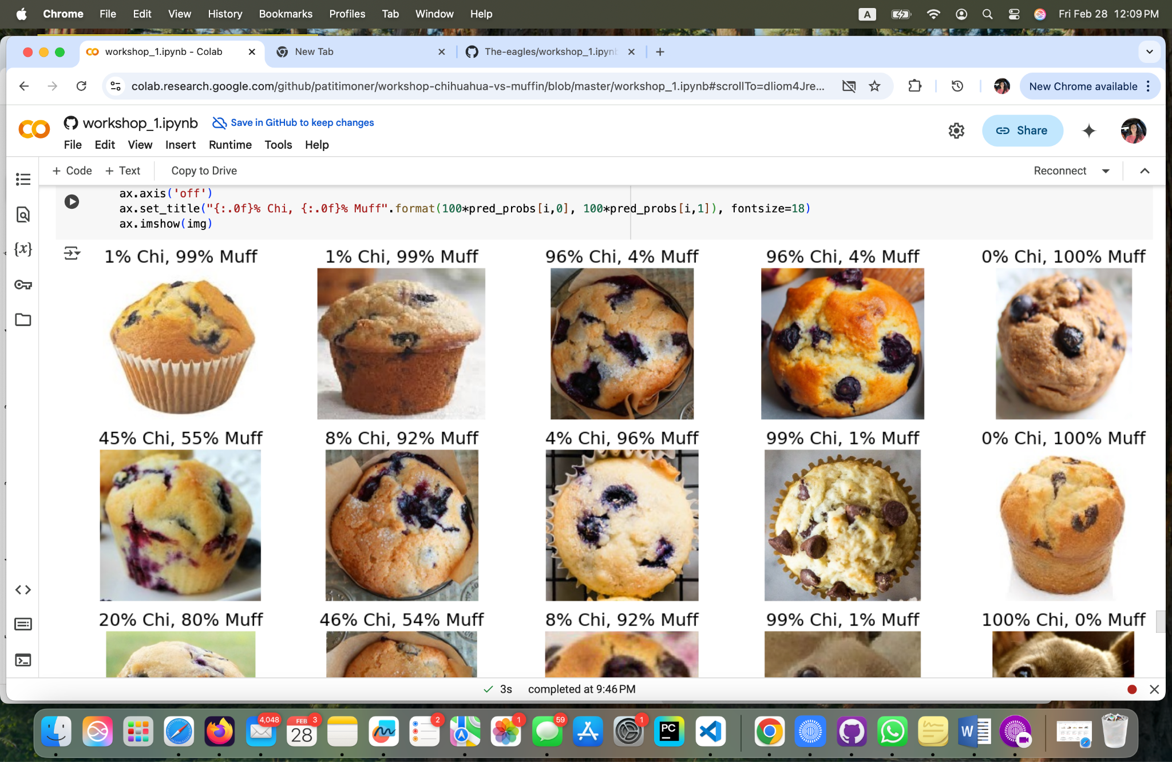

**Fig 18 - Yoana Cook: Visualizing Model Predictions on Validation Images Part 2**

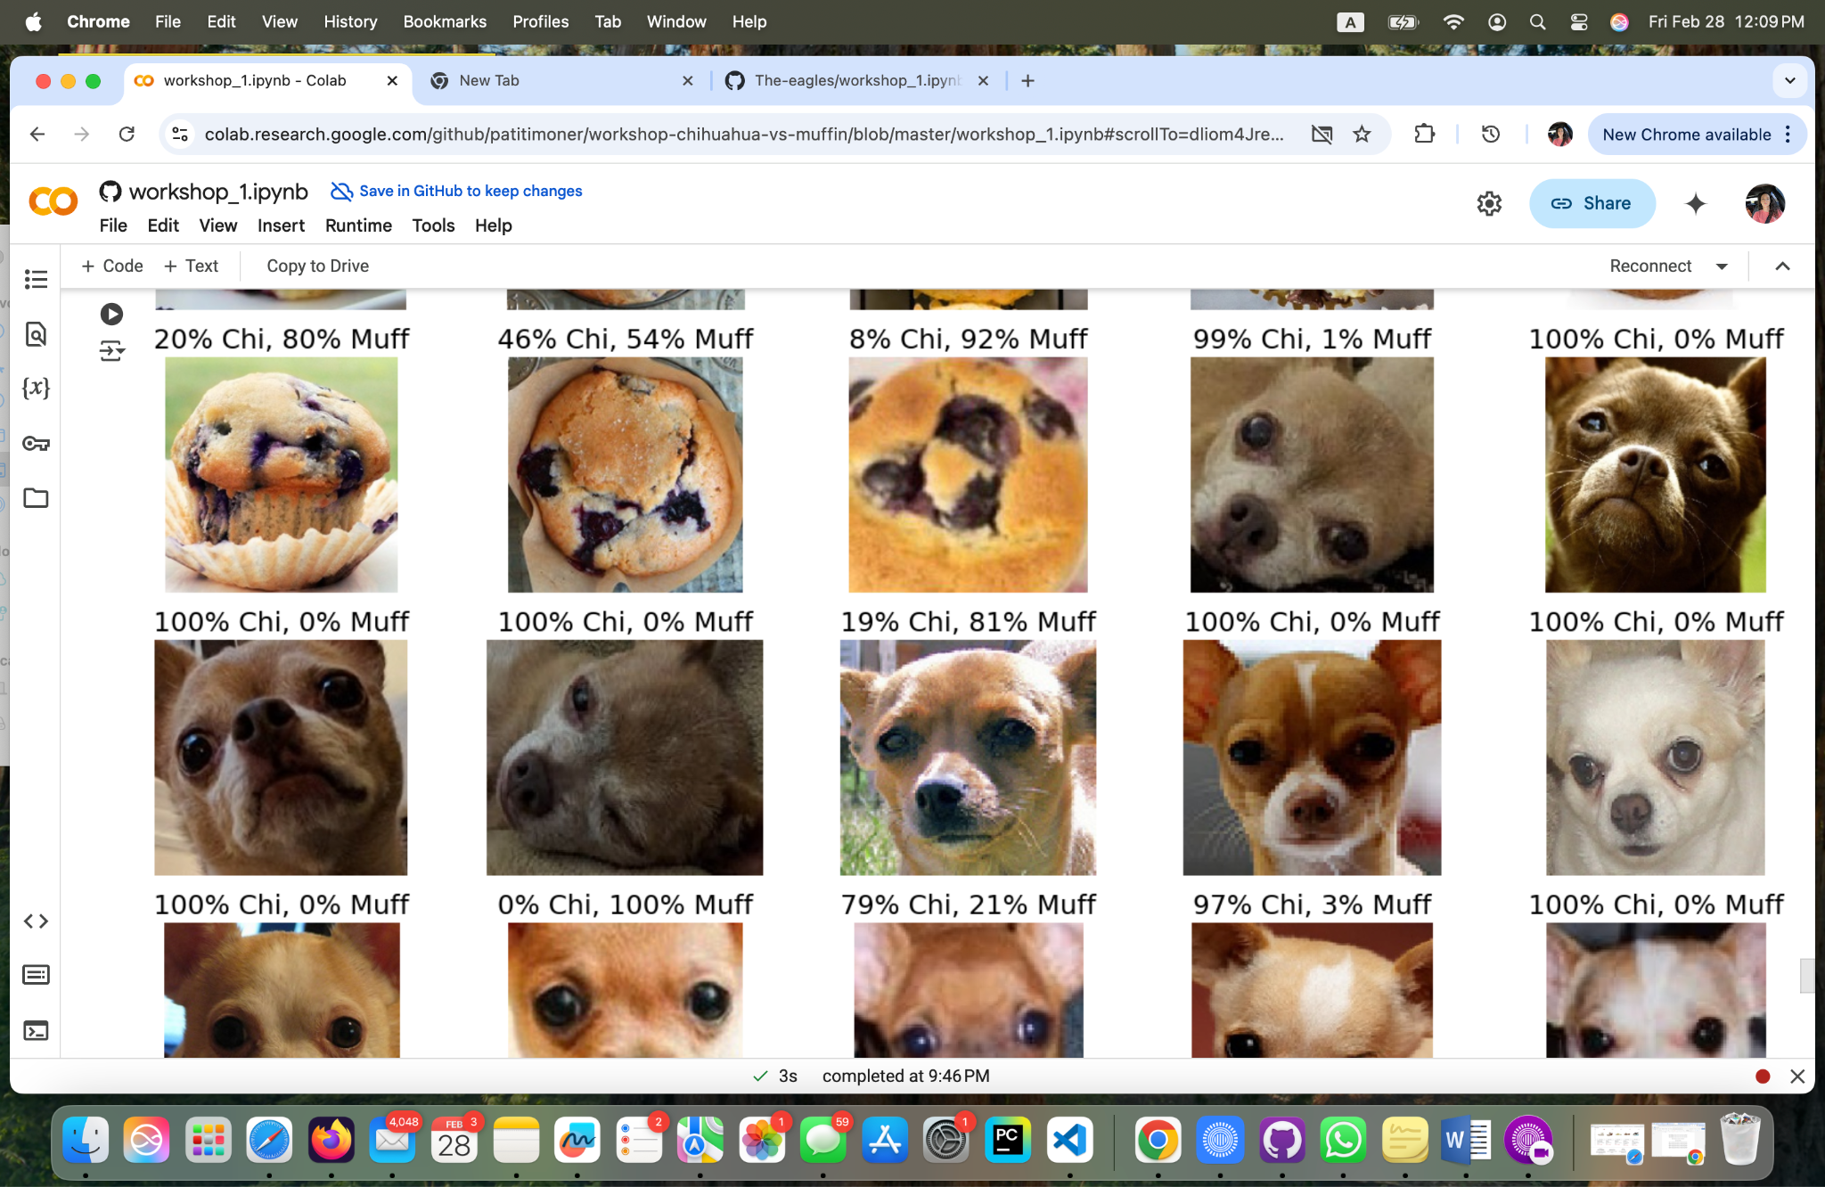

**Fig 19 - Yoana Cook: Visualizing Model Predictions on Validation Images Part 2**

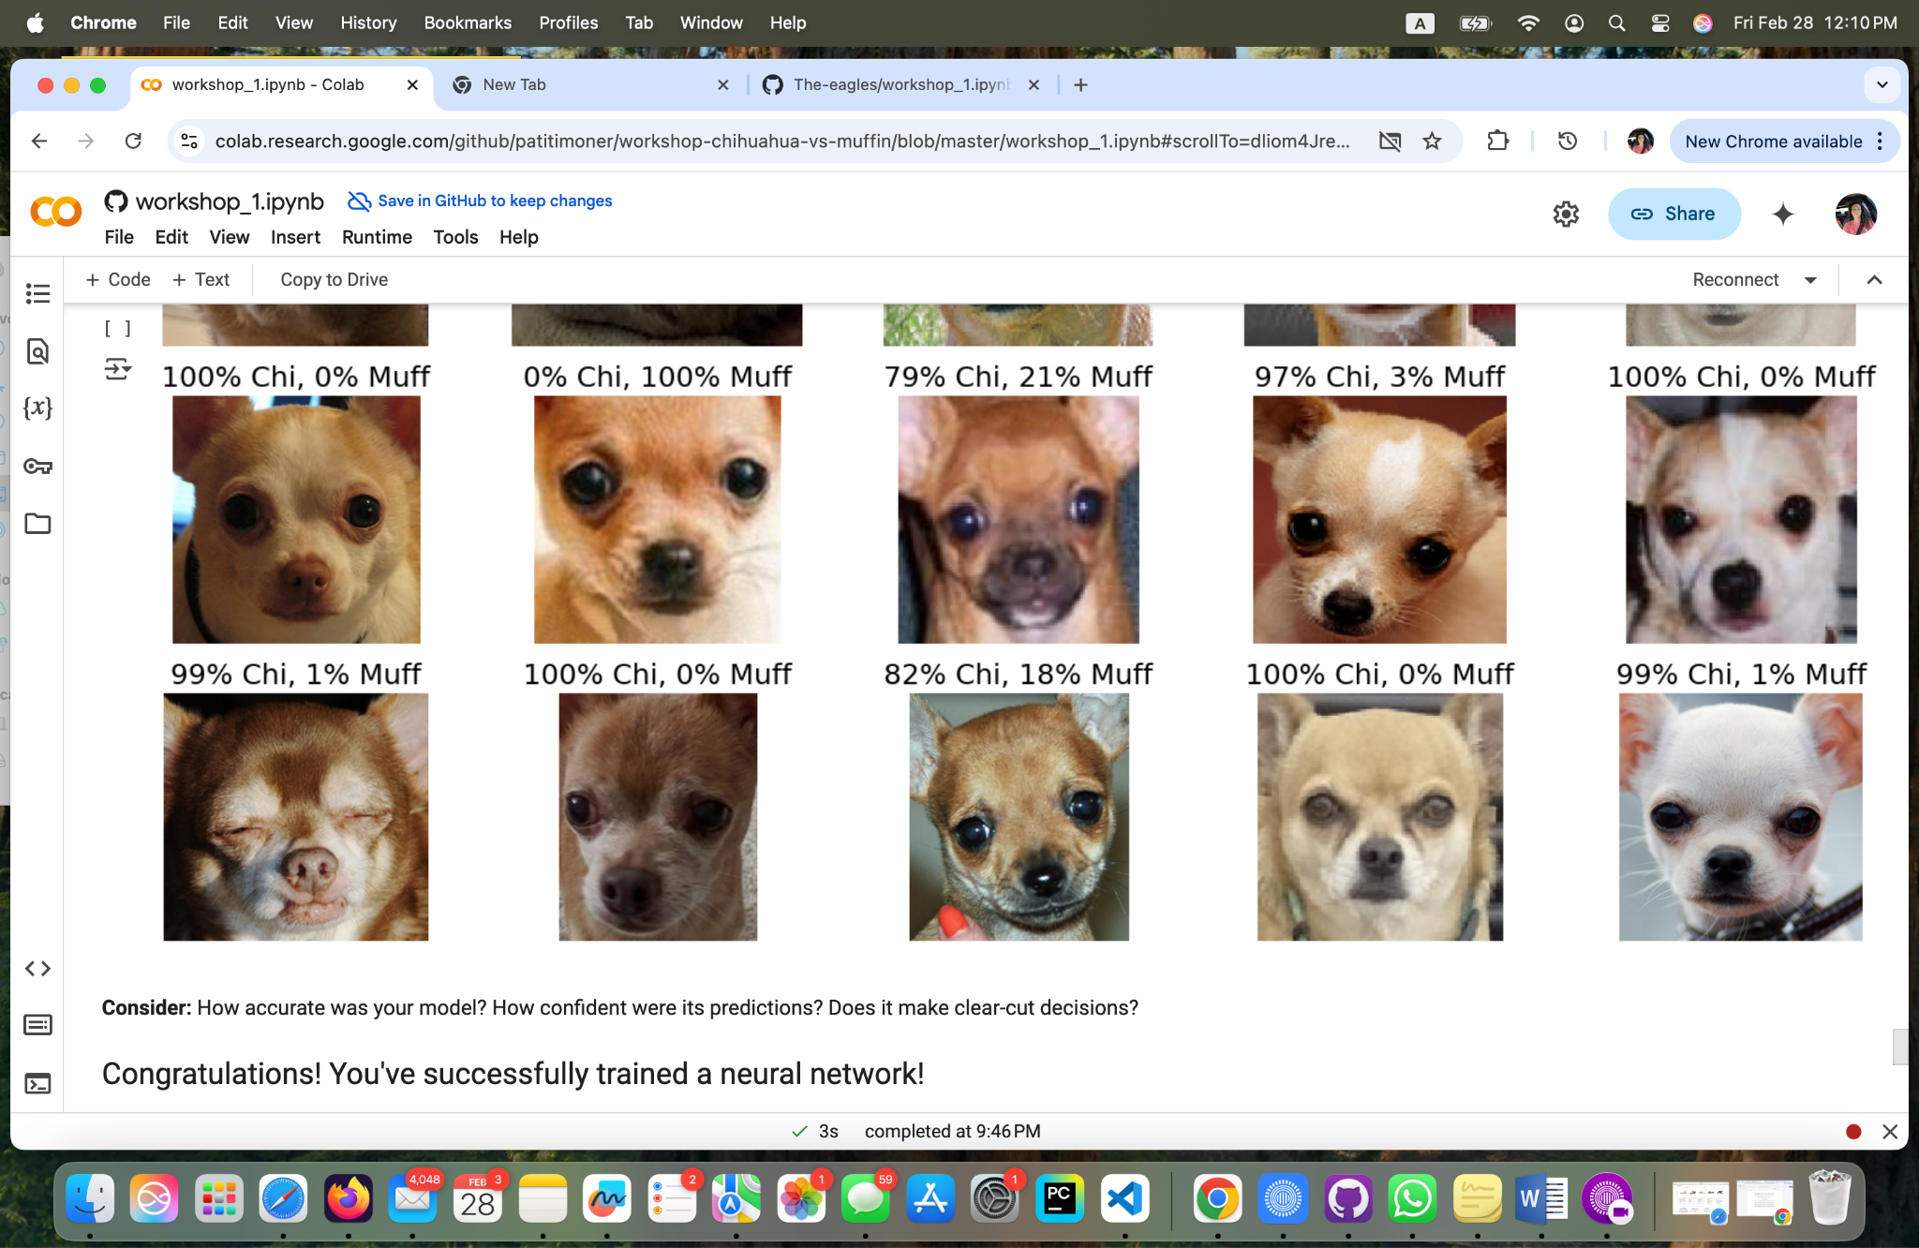

**Fig 20 - Yoana Cook: Visualizing Model Predictions on Validation Images Part 3**

**Personal Reflection:**

**Brooke Broderick**

**Matthew Choo**

* **After working in this lab, it was both interesting and challenging. I had to add codes that were needed to start the lab and have to change the original code with new codes added. From Figures 23 - 45, they show both the codes and results for muffins and Chihuahuas. Had to change codes from the transform to convert images to tensors section (Fig 31), the transforms into imagefolder constructor section (Fig 32), from dataloaders to datasets (Fig 34) and the train loop (Fig 38 and 39). Overall I was able to understand the workshop file and the coding it was given.**

**Cameroun White**

* **This was a very informative lab that I actually didn’t mind doing. The end goal was to successfully build a neural network that we input data to have an accurate output to distinguish between Chihuahuas and muffins. There were a few code errors but with repetition the code was able to run effectively Implementing transformations, like converting our image data to tensors so our NN could understand along with having appropriate pixels so the model processes the images correctly to distinguish between Chihuahua or muffin. Overall this lab helped get a better understanding in the realm of image classification but I will continue to dive deeper into it to have a more confident understanding.**

**Melvis Maduagwu**

* **This lab introduced me to Image classification with machine learning. In this lab, we created a neural network to classify images of chihuahuas and muffins. We imported the necessary libraries to aid in the building of the neural network, we loaded the data, separated them into test and training data 80% to train and 20% to test. Lastly, we examined the model’s performance. In my opinion, the model’s predictions weren’t accurate and I think it could be better, probably because the data wasn't enough for the Model. I hope to work on more projects like this in the future to really understand how these machine learning models work.**

**Erick Banegas**

* **This project involved implementing a neural network in PyTorch to classify images of chihuahuas and muffins, overcoming various technical challenges such as input dimension errors, model configuration, and CPU-GPU compatibility. We successfully loaded and preprocessed data, designed and trained a fully connected neural network, and visualized predictions effectively. Through debugging and structural adjustments, we ensured stable performance, laying the foundation for future improvements using convolutional neural networks (CNNs) and transfer learning. This work demonstrates the power of neural networks in image classification and opens the door to optimizations that could enhance model accuracy for more complex applications.**

**NancyChieu**

* **This assignment helps us to expand our skills in using Google Colab and GitHub to classify the different images between chihuahuas and muffins. The coding was challenging, however, I was able to correct numerous errors by reading the instructions. With the help of our team leader, Matthew, I finally completed the assignment and gained confidence in writing coding in Google Colab and saved it to GitHub. Coding can be tricky and time consuming. It needs to be exact and precise, if not I could be running in a circle. We humans can detect the difference between chihuahua and muffin easily, however, neural networks require a lot of inputs, hidden layers to be able to generate the image classification. CNN (convolutional neural networks) and transfer learning are parts of deep learning which we will learn more in the future modules. I am looking forward to practicing all the skills learned in this course so that I can apply them to real life situations.**

**Yoana Cook**

* This project was such a fun experience! The goal was to build a model that could tell the difference between pictures of chihuahuas and muffins. I remember the first time I learned about this project it was in class Theory and History of AI and I remember thinking, "How hard could it be? They look so different!" But as I further explored the project, I realized there is a lot more to it than meets the eye or the blueberry. :)
* I begun this project by organizing the images into folders for training and validation. Then, applied some transformations, such as resizing the images, converting them to tensors, and normalizing the pixel values. This step was important because it made sure the data was ready for the model to process.
* Using a simple neural network with a few layers. The model took the image data, processed it through the layers, and eventually predicted whether the image was a chihuahua or a muffin.
* Training the data was the most fun part. Using a loss function (CrossEntropyLoss) to measure how wrong the model’s predictions were and an optimizer (SGD) to help the model learn from its mistakes. Watching the model improve over time was like watching myself debug this code, it started off wobbly but got better with practice!
* After training the model, followed by testing the model on some validation images. It was amazing to see the model’s predictions displayed alongside the images. Some were spot on, like "95% chihuahua," while others were a bit funny, like a muffin being mistaken for a chihuahua, and the white chihuahua, was predicted %100. It made me realize how tricky it can be for a model to distinguish between those blueberry eyes.
* I learned that even though chihuahuas and muffins look very different to us, a model needs a lot of data and fine-tuning to distinguish between both. Small details like lighting, angles, and textures can really throw it off the model. Cleaning and preparing the data took more time than I expected, but it was worth it. Without good data, the model would not have learned anything useful. Training a model takes time, and it is not always perfect on the first try. There had to be applied a few tweaks, such as the learning rate and the number of epochs to get better results.
* Debugging was a big part of the process. I kept running into errors, like mismatched tensor shapes or issues with the data paths. Also, the code provided was incomplete and contains placeholders (?) and syntax errors. It took a while to figure out what was going wrong, but solving those bugs felt like cracking a puzzle.
* This project made me think about how useful image classification can be in real life. For example: Pet Recognition: Apps that can identify dog breeds or even lost pets; Food Classification: Helping people track their diet by identifying foods in photos; Security: Detecting objects or people in surveillance footage.
* Overall, this project was a great introduction to machine learning and image classification. It was challenging at times, but seeing the model make accurate predictions was incredibly rewarding. It made me appreciate how much work goes into building AI systems and how powerful they can be when done right. I am excited to keep learning and maybe even build something on my own in the future!

**GitHub Link**

**Brooke Broderick**

**Matthew Choo**

* [**https://github.com/MattChoo0/Workshop_1**](https://github.com/MattChoo0/Workshop_1)

**Cameroun White**

* [**https://github.com/OhMyGodCam/workshop_ipynb.git**](https://github.com/OhMyGodCam/workshop_ipynb.git)

**Melvis Maduagwu**

* [**https://github.com/Melvis-07/Workshop_1**](https://github.com/Melvis-07/Workshop_1)

**Erick Banegas**

**NancyChieu**

* **https://github.com/nchieu2025/jupyter-exploration.git/workshop_1.ipynb**

**Yoana Cook**

* [**https://github.com/YoanaKC/The-eagles/blob/main/workshop_1.ipynb**](https://github.com/YoanaKC/The-eagles/blob/main/workshop_1.ipynb)

Bibliography

Gillis, Alexander S., et al. “What Is a Convolutional Neural Network (CNN)?: Definition

from TechTarget.” Search Enterprise AI, TechTarget, 25 Nov. 2024,

www.techtarget.com/searchenterpriseai/definition/convolutional-neural-network.

Ibm. “What Is Transfer Learning?” IBM, 19 Dec. 2024,

[ibm.com/think/topics/transfer-learning#:~:text=Transfer%20learning%20is%20a%20machine,im](http://ibm.com/think/topics/transfer-learning#:~:text=Transfer%20learning%20is%20a%20machine,im)

prove%20generalization%20in%20another%20setting.

“Image Classification.” Papers With Code,

[paperswithcode.com/task/image-classification#:~:text=Image%20Classification%20is%20a%20f](http://paperswithcode.com/task/image-classification#:~:text=Image%20Classification%20is%20a%20f)

undamental,pertains%20to%20single%2Dobject%20images. Accessed 23 Feb. 2025.